GP 108 : : Mini Project

Design of a Flow Rate Sensor

Irfan M.M.M. (E/15/138)

Ishanthi D.S. (E/15/139)

Jaliyagoda A.J.N.M. (E/15/140)

Jayakody J.A.D.M. (E/15/141)

Jayalath A.H.G.D. (E/15/142)

Jayamangala H.P. (E/15/143)

**Thermal Mass Flow**

Thermal mass flow meters measure the mass flow rate of gases and liquids directly. Volumetric measurements depend on all ambient and process conditions that make changes in unit volume or indirectly depend on pressure drop, while mass flow measurement does not depend on changes in viscosity, density, temperature, or pressure.

Thermal flow meters use the thermal properties of the fluid to measure the flow of a fluid flowing in a pipe or duct. They are often used in monitoring or controlling mass-related processes.

This meter can be used in high-pressure and high-temperature, and in special materials including glass, Monel and PFA. Flow-through designs are used to measure small flows of pure substances where heat capacity is constant, while bypass and probe-type designs can detect large flows in ducts, flare stacks, and dryers.

**Theory**

Thermal Mass Flow Meters can operate in two different methods. They are,

* By absorbing a known amount of heat into the flow and measuring the temperature difference.
* By maintaining a constant temperature difference and measuring the amount of energy absorbed.

The components of a basic thermal mass flow meter include two temperature sensors and an electric heater between them. The heater can be inserted into the stream or it can be externally connected to the pipe.

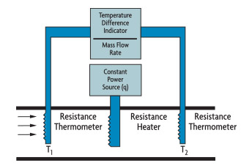

Immersion Heater

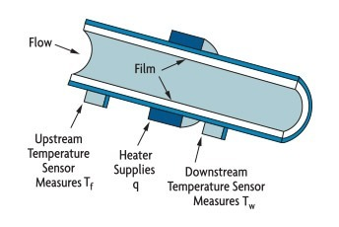

Externally Heated Tube

In the direct heat flow meter, a fixed amount of heat is supplied by an electric heater. When the fluid flows through the pipe, resistance temperature detectors (RTDs) measure the temperature rise. Then the mass flow rate is calculated by using following equation.

m = Kq/(Cp(T2 - T1))

m-The mass flow

T2 - T1 -Temperature difference

k- Meter coefficient

q-Electric heat rate

Cp-Specific heat of the fluid  